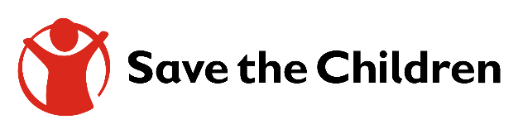

Terms of Reference (TOR) for Agency to Produce GFFO Design layouts and Animation

Name of TA provider: Creative Agency
Office/places to be visit: CO – Port Sudan

Period of task request:
- Start: ASAP
- Delivery before Feb 1st
Objectives:
The main objectives of the task:
Create 5 animations based on 5 themes:
Topics include:
- Hygiene practices
- Vector control
- Cholera
- Use of Aqua Tabs (soon to be shared)
- Dengue prevention (soon to be shared)

Animation Style
Tone & Feel
Story Overview (Concept Summary)

Format & Duration
- Total duration: 3–5 minutes
- Versions required:
  - Full version (3–5 min)
  - 30-second cut-down for social media
  - 15-second teaser (optional)
- Languages: Arabic & English
- Subtitles: Required in both languages

Support Needed from Country Offices:
- Local coordination Hamid Abdusalam and ACCM Team
- Guidance on direction GFFO Team and Hamid

Expected Outputs:
- Animated film (3–5 min)
- Social versions (30 sec + optional 15 sec)
- English & Arabic versions
- Subtitle files
- All source files (Adobe After Effects / Illustrator / etc.)

